**UNIT-II**

**SHORT CIRCUIT ANALYSIS**

**Per Unit Representation of Power Systems:**

For single-phase systems, or balanced three-phase systems (when solved as a single line with a neutral return), the base quantities in the impedance diagram are per phase volt-ampere in MVA and line-to-neutral voltage in kV. The following formulae relate the various quantities:

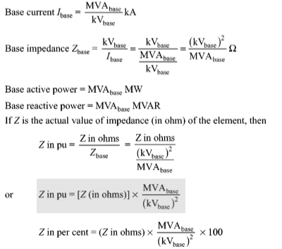

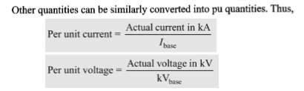

**Conversion of per unit Quantities from One Base to Another Base:**

If Zold is the pu impedance on a given set of base quantities MVAold and kVOld, and Znew is the pu impedance on a new set of base quantities MVAnew and kVnew then

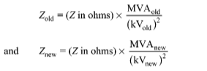

From the above equations the relationship between the old and new per unit values is

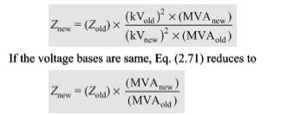

**Advantages of Per unit Values:**

1. Per unit values of quantities, when the base values are appropriately selected, are independent of the side of the transformer to which they are connected. On the other hand, ohmic values have to be referred to one side of the transformer.
2. Per unit values are independent of the type of the power system, that is, whether the power system is single phase or three phase.
3. The equipment, supplied by manufacturers, provides the equipment parameters in pu on the name plate rating.
4. Analyses of power systems are simplified considerably by using pu values.

**Reactance Diagrams**

In power system analysis it is necessary to draw an equivalent circuit for the system. This is an impedance diagrams. However, in several studies, including short-circuit analysis it is sufficient to consider only reactance’s neglecting resistances. Hence, we draw reactance diagrams. For 3-phase balanced systems, it is simpler to represent the system by a single line diagram without losing the identity of the 3-phase system. Thus, single line reactance diagrams can be drawn for calculation.

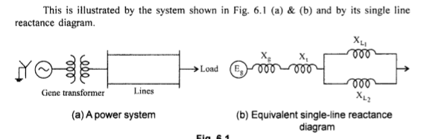

**Calculation of 3-phase Short-Circuit Currents:**

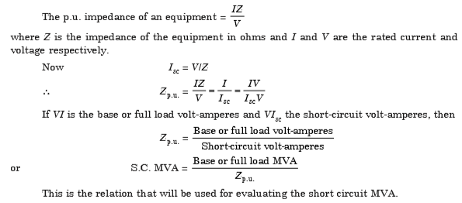

**Reactors**:

Reactor is a coil which has high inductive reactance as compared to its resistance and is used to limit the short circuit current during fault conditions. If an iron cored inductor is expected to maintain constant reactance for currents two to three times its normal value it will turn out to be very costly and heavy. Therefore air cored coils having constant inductance are generally used for current limiting reactors.

Various types of reactors are

**Generator Reactors:**

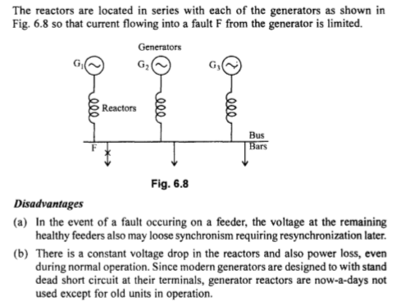

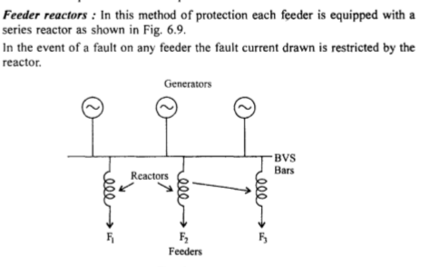

Disadvantages:

I. Voltage drop and power loss still occurs in the reactor for a feeder fault. However, the voltage drop occurs only in that particular feeder reactor.

2. Feeder reactors do not offer any protection for bus bar faults. Nevertheless, bus-bar faults occur very rarely. As series reactors inhererbly create voltage drop, system voltage regulation will be impaired. Hence they are to be used only in special case such as for short feeders of large cross-section.

**Bus bar reactors:**

In both the above methods, the reactors carry full load current under normal operation. The consequent disadvantage of constant voltage drops and power loss can be avoided by dividing the bus bars into sections and inter connect the sections through protective reactors. There are two ways of doing this.

(a) **Ring system:** In this method each feeder is fed by one generator. Very little power flows across the reactors during normal operation. Hence, the voltage drop and power loss are negligible. If a fault occurs on any feeder, only the generator to which the feeder is connected will feed the fault and other generators are required to feed the fault through the reactor.

(b) **Tie-bar system:** This is an improvement over the ring system. This is shown in Fig. 6.11. Current fed into a fault has to pass through two reactors in series between sections.

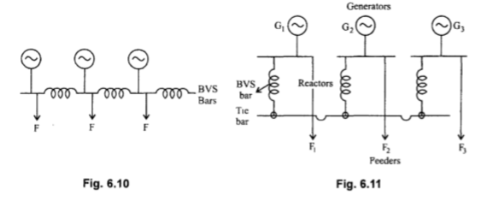

The only disadvantage is that this systems requires an additional bus-bar system, the tie-bar.

**Symmetrical Components:**

**Positive Sequence Components**

The positive sequence components are equal in magnitude and displayed from each other by 120o with the same sequence as the original phases. The positive sequence currents and voltages follow the same cycle order of the original source. In the case of typical counter clockwise rotation electrical system, the positive sequence phasor are shown in figure below . The same case applies for the positive current phasors. This sequence is also called the “abc” sequence.

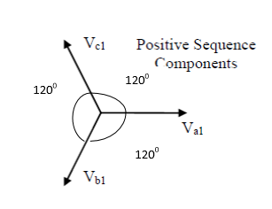

**Negative Sequence Components**

This sequence has components that are also equal in magnitude and displayed from each other by 120o similar to the positive sequence components. However, it has an opposite phase sequence from the original system. The negative sequence is identified as the “acb” sequence. The phasors of this sequence are shown in Fig below, where the phasors rotate anti- clockwise. This sequence occurs only in case of an unsymmetrical fault in addition to the positive sequence components**.**

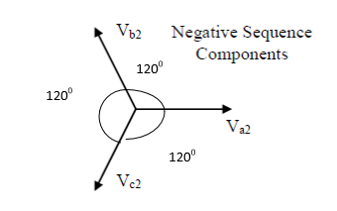

**Zero Sequence Components**

In this sequence, its components consist of three phasors which are equal in magnitude as before but with a zero displacement. The phasor components are in phase with each other. This is illustrated in figure. Under an asymmetrical fault condition, this sequence symbolizes the residual electricity in the system in terms of voltages and currents where a ground or a fourth wire exists. It happens when ground currents return to the power system through any grounding point in the electrical system. In this type of faults, the positive and the negative components are also present. This sequence is known by the symbol “0”.

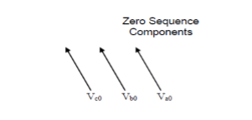

**The Operator "a" :**

In view of the phase displacement of 120°, an operator "a" is used to indicate the phase displacement, just as j operator is used to denote 90 phase displacement

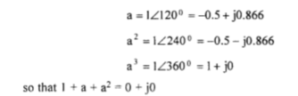

**Symmetrical Components of Unsymmetrical Phases:**

With the introduction of the operator "a" it is possible to redefine the relationship between unbalanced phasors of voltages and currents in terms of the symmetrical components.

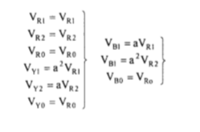

The voltage and current phasors for a 3-phase unbalanced system are then represented by

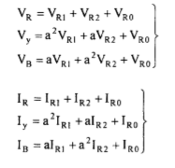

The above equations can be put in matrix form considering zero sequence relation as the first for convenience

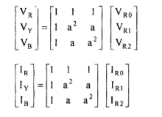

Then the sequence components can be obtained from the phase values as

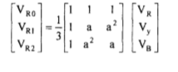

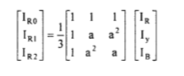

**THREE-SEQUENCE IMPEDANCES AND SEQUENCE NETWORKS** :

Positive sequence currents give rise to only positive sequence voltages, the negative sequence currents give rise to only negative sequence voltages and zero sequence currents give rise to only zero sequence voltages, hence each network can be regarded as flowing within in its own network through impedances of its own sequence only.

In any part of the circuit, the voltage drop caused by current of a certain sequence depends on the impedance of that part of the circuit to current of that sequence. The impedance of any section of a balanced network to current of one sequence may be different from impedance to current of another sequence.

The impedance of a circuit when positive sequence currents are flowing is called positive sequence impedance, When only negative sequence currents are flowing the impedance is termed as negative sequence impedance. With only zero sequence currents flowing the impedance is termed as zero sequence impedance.

The analysis of unsymmetrical faults in power systems is carried out by finding the symmetrical components of the unbalanced currents. Since each sequence current causes a voltage drop of that sequence only, each sequence current can be considered to flow in an independent network composed of impedances to current of that sequence only.

The single phase equivalent circuit composed of the impedances to current of any one sequence only is called the sequence network of that particular sequence. The sequence networks contain the generated emfs and impedances of like sequence. Therefore for every power system we can form three- sequence network s. These sequence networks, carrying current Ia1, Ia2 and Ia0 are then inter-connected to represent the different fault conditions.

**SEQUENCE NETWORKS OF SYNCHRONOUS MACHINES**

An unloaded synchronous machine having its neutral earthed through impedance, Zn, is shown in figure below. A fault at its terminals causes currents Ia, Ib and Ic to flow in the lines. If fault involves earth, a current in flows into the neutral from the earth. This current flows through the neutral impedance Zn. Thus depending on the type of fault, one or more of the line currents may be zero. Thus depending on the type of fault, one or more of the line currents may be zero.

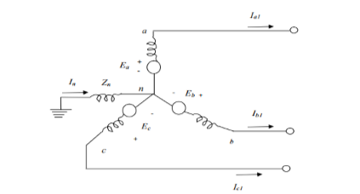

**POSITIVE SEQUENCE NETWORK**

The generated voltages of a synchronous machine are of positive sequence only since the windings of a synchronous machine are symmetrical. The positive sequence network consists of an emf equal to no load terminal voltages and is in series with the positive sequence impedance Z1 of the machine shown in the figure below. The neutral impedance Zn does not appear in the circuit because the phasor sum of Ia1, Ib1 and Ic1 is zero and no positive sequence current can flow through Zn. Since it’s a balanced circuit, the positive sequence, the reference bus for the positive sequence network is the neutral of the generator. The positive sequence impedance Z1 consists of winding resistance and direct axis reactance. The positive sequence voltage of terminal a with respect to the reference bus is given by:

Va1= Ea - Z1*Ia1

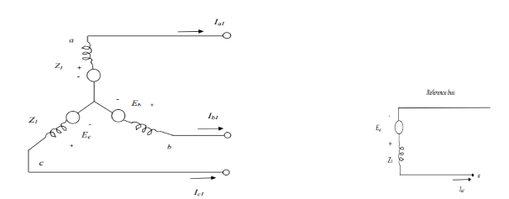

**NEGATIVE SEQUENCE NETWORK**

A synchronous machine does not generate any negative sequence voltage. The flow of negative sequence currents in the stator windings creates an mmf which rotates at synchronous speed in a direction opposite to the direction of rotor, i.e., at twice the synchronous speed with respect to rotor. Thus the negative sequence mmf alternates past the direct and quadrature axis and sets up a varying armature reaction effect. It not necessary to consider any time variation of X2 during transient conditions because there is no normal constant armature reaction to be effected. The figure below shows the negative sequence currents paths and the negative sequence network respectively on a single phase basis of a synchronous machine. The reference bus for the negative sequence network is the neutral of the machine. Thus, the negative sequence voltage of terminal a with respect to the reference bus is given by:

Va2= -Z2Ia2

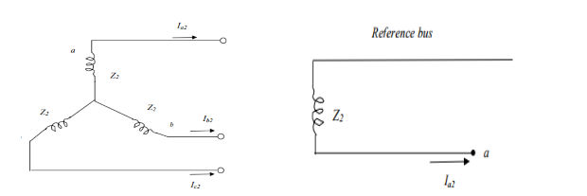

**ZERO SEQUENCE NETWORK**

No zero sequence voltage is induced in a synchronous machine. The flow of zero sequence currents in the stator windings produces three mmf which are in time phase. If each phase winding produced a sinusoidal space mmf, then with the rotor removed, the flux at a point on the axis of the stator due to zero sequence current would be zero at every instant. The zero sequence currents flow through the neutral impedance Zn and the current flowing through this impedance is 3Ia0 .

Figure shows the zero sequence current paths and zero sequence network respectively, and as can be seen, the zero sequence voltage drop from point a to ground is - 3Ia0Zn –Ia0Zg0 where Zg0 is the zero sequence impedance per phase of the generator. Since the current in the zero sequence network is Ia0 this network must have an impedance of 3Zn +Zg0. Thus, Z0 =3Zn +Zg0. The zero sequence voltage of terminal a with respect to the reference bus is

Va0 = -Ia0Z0

